**Lesson 4 Demo 1**

**Perform Custom Formatting - Numbers**

**Objective:** Demonstrate how to use custom formatting to format   
large numbers

**Tools required:** Excel.

**Prerequisites:** None

**Steps to be followed:**

**Step 1: Open the Excel file.**

* 1. Open the file named **Formatting.xlsx.**

**Step 2: Set custom formatting on the number column.**

* 1. Choose the column **Net Sales**

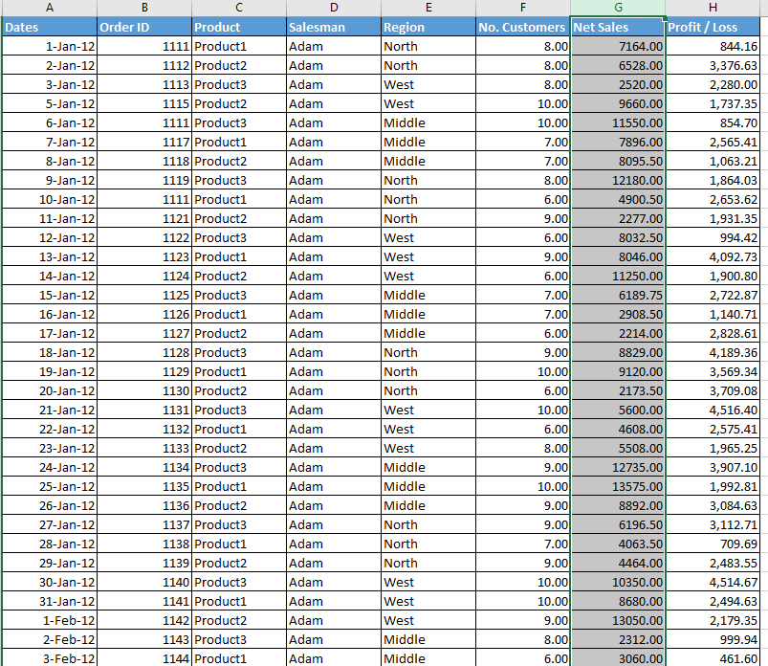

* 1. Click on **More Number Formats** under Format in the Home tab

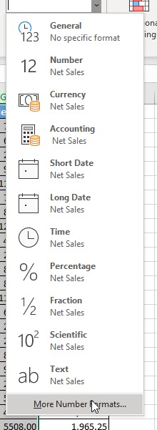

* 1. Choose Custom and type **#,##0.0,K** in the Type text box. Click on OK

* 1. The formatted numbers appear as shown:

